Performance Evaluation of a Linear Tapered Rectangular Waveguide in terms of power distribution analysis per ports and S-parameters.
Test Case 1:
Simulate a linear tapered Rectangular Waveguide using CST Studio Suite, analyze its
electromagnetic behavior, and examine the power distribution among ports over a specified frequency range.
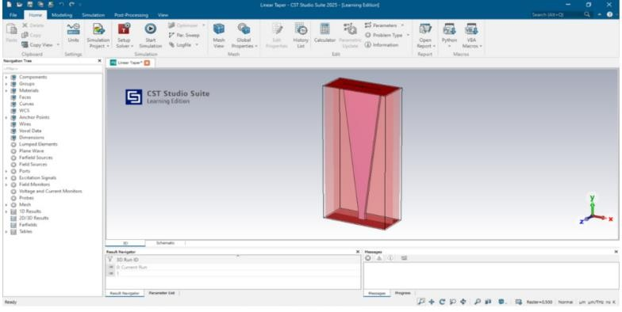
Output:
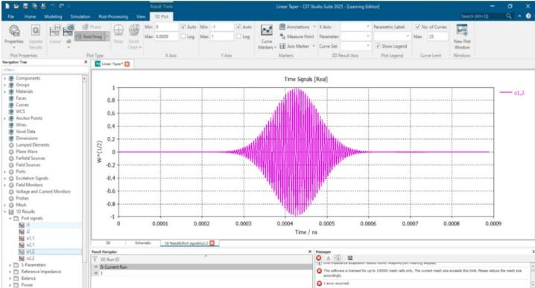
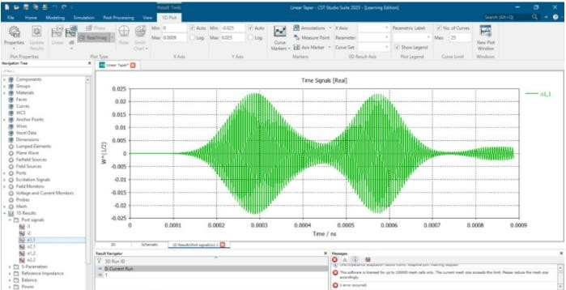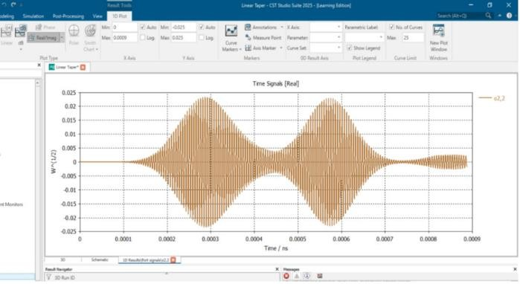
Test Case 2:
Simulate a linear tapered Rectangular Waveguide using CST Studio Suite, analyze its electromagnetic behavior, and examine the S parameters.


Output:
